

Course program
AOTrauma Masters Course

May 03 - 06, 2014 Krakow, Poland

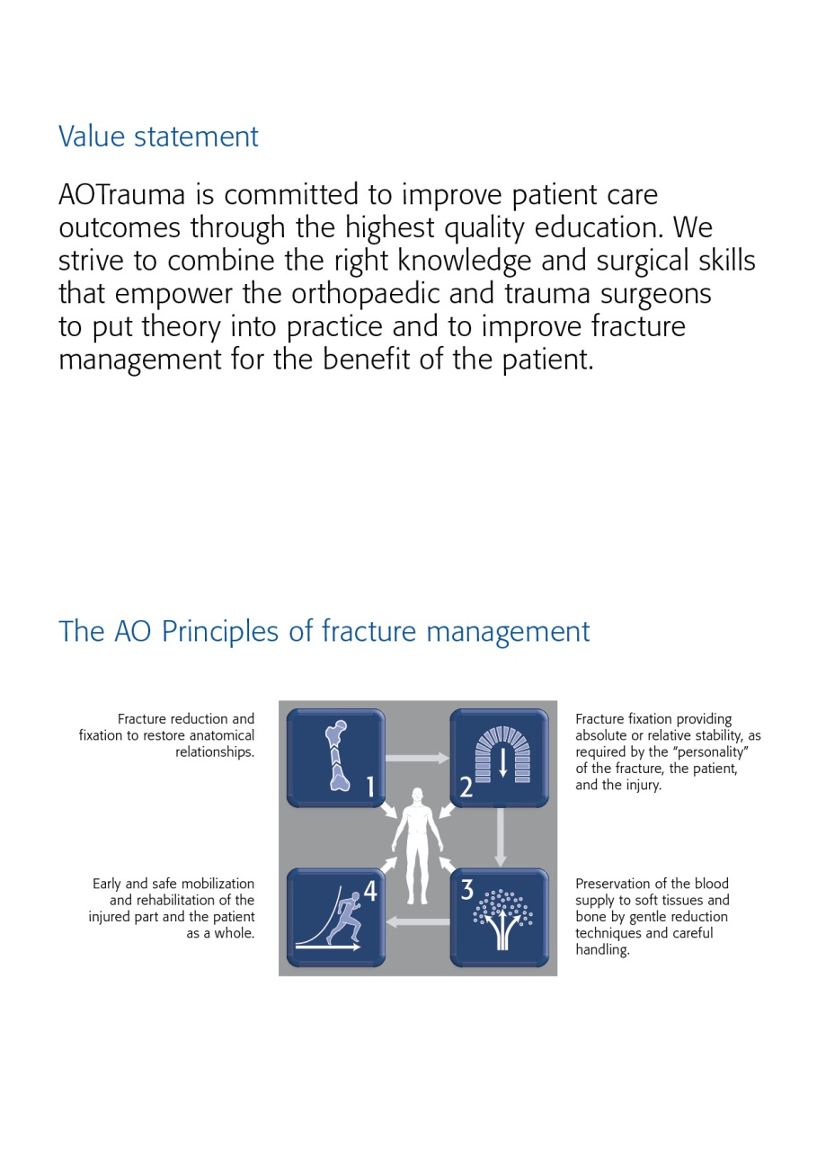

Dear AOTrauma course participant
It is with great pleasure and honor that I welcome you on behalf of AOTrauma and your local and international faculty to the AOTrauma MID Regional Courses.
This year the courses take place in Prague, with participants from Eastern, Central, and South-Eastern Europe.
Our previous excellent courses have been conducted by an international leading faculty from outside our region. Over the past couple of years, we have accomplished to consolidate our continuously growing group gradually and have established our own faculty. In our current regional educational programs for faculty and chairpersons we have improved our educational skills and dealt specifically with problems originating from the variety of countries, cultures, and languages constituting our region.
At the same time, we have learned to profit from our cultural diversity, the abundance of ideas, and vast experience of the different experts. We have identified our common goals in clinical research and primarily educational fields and determined them distinctively.
We hope you will enjoy the courses, make new friends, and return home with newly acquired knowledge, skills, and attitudes. We are confident that your participation demonstrates your dedication to your patients and we encourage you to continue your education and join our collective efforts in the region through AOTrauma.
Finally, we would like to thank Synthes. The logistic effort involved in organizing such a course is truly massive and it could not take place without their valuable support.

Yours sincerely,

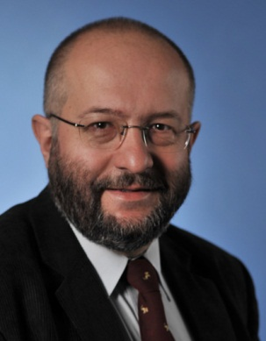
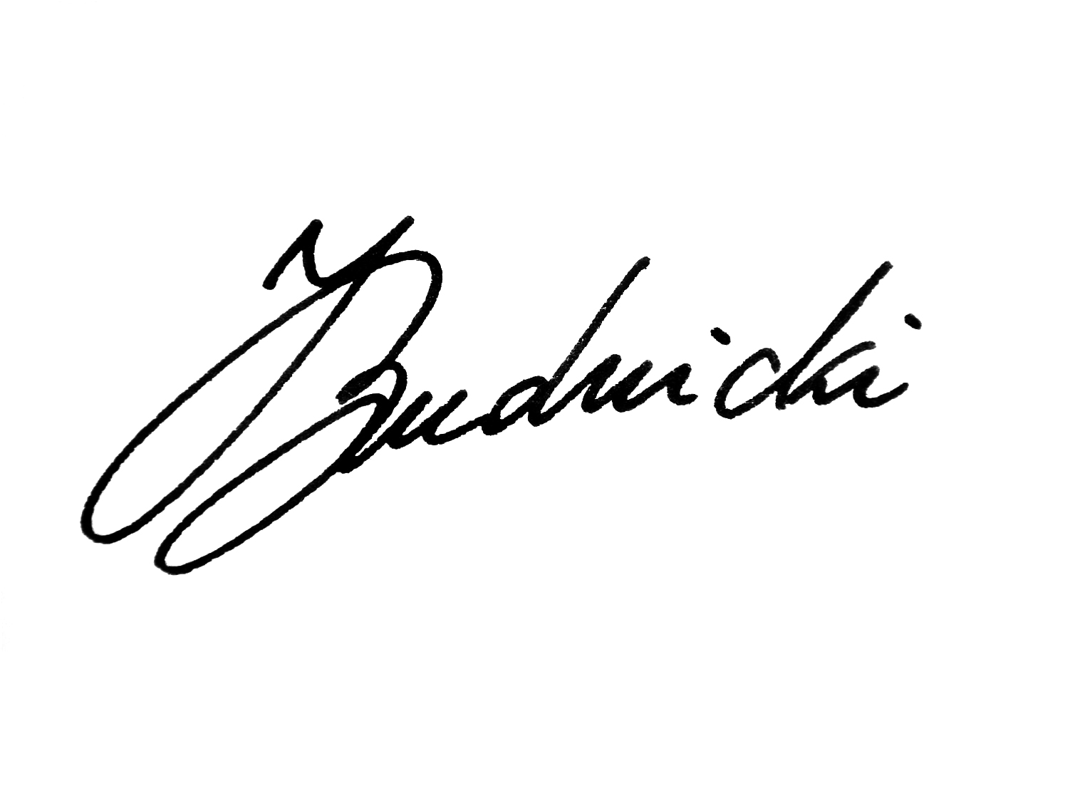
Haluk Agus
Overall Chair of AOT MID
Regional Courses in Krakow 2014

PS: Your experiences with us, over the next few days, will result in the adoption of new and meaningful knowledge, skills, and understanding that we hope will translate into improved patient care.

The first AO Course was held in Davos in 1960—these early courses pioneered psychomotor techniques by teaching practical skills of AO Techniques. Since those early days over 250,000 surgeons and 135,000 ORP staff from over 110 countries have attended AO Courses—we now launch AOTrauma to move our education to the next level.

Content
1 Value statement
1 The AO principles
2 Dear AOTrauma course participant
3 Goal of the course
3 Target participants
3 Course objectives
4 Course description
4 Chairpersons
5 Faculty
6 Saturday, May 11, 2013
7 Sunday, May 12, 2013
9 Monday, May 13, 2013
10 Tuesday, May 14, 2013
12 Course organization
12 Course information
12 Course logistics
14 Course venue
14 Upcoming courses

Goal of the course
The AOTrauma Masters Courses address the latest concepts and best practices at the highest level. The AOTrauma Masters Course—Upper Extremity focuses on the best available evidence and latest techniques in operative fracture management dealing with the toughest upper extremity trauma problems. Our goal is to foster discussion, making use of real cases and provoking open debate between participants and faculty members, complemented by lectures presenting the current evidence. To round off the program, a joint session with our colleagues from the Masters Courses—Lower Extremity and Complications and Complex Fractures offer a fresh perspective on some common themes, practical application of evidence, and insights into how the future of orthopedic trauma can be applied in the clinic today.

Target participants
Participants must have already completed the AOTrauma Basic Principles and Advanced Principles of Fracture Management Courses. They should be actively involved in trauma management and preferably have more than 10 years of experience in orthopedic trauma surgery. They should be willing to share their ideas and opinions and get involved. In order to optimize the educational experience for all, it is essential that participants have a very good knowledge of English.

Course objectives
Upon completion of this course participants should be able to:
- Explain and discuss current management methods for fractures of the scapula, clavicle, and floating shoulder
- Apply the latest principles and discuss current treatment techniques for complex proximal humeral fractures, shoulder fracture dislocations, and complications of humeral shaft fractures
- Describe injury patterns and develop treatment plans for difficult fractures of the olecranon, radial head, and elbow, including fracture dislocations
- Evaluate and discuss the management of complex fractures of the forearm as well as distal radial fractures and injuries to the proximal carpus
- Identify and address gaps in patient outcomes in your clinical practice
- Perform the currently preferred and accepted surgical approaches for management of upper extremity injuries

Course description
This course is targeted at surgeons with significant surgical expertise who are willing to share and explore their experiences with their peers and faculty. The AOTrauma Masters Course—Upper Extremity is built around open discussion groups followed by interactive case-based presentations by experts in the field. They will introduce the latest evidence, concepts, and techniques in the management of upper extremity fractures. It will also introduce the latest approaches and current opinions on implants for particular problems. Participants will practice a variety of approaches on anatomical specimens. This course shares a joint session with the Masters Courses—Lower Extremity and Complications and Complex Fractures, addressing common themes and making use of interactive learning approaches.

Chairpersons

Matej Kastelec Steven Velkes
Slovenia Israel

Faculty
Brilej | Drago | Slovenia
Cicvaric | Tedi | Croatia | Tedi_cicvaric@yahoo.com
Cimerman | Matej | Slovenia | Matej.cimerman@kclj.si
Demirtas | Mehmed | Turkey
Grechenig | Wolfgang | Austria | Wolfgang.grechenig@klinikum-graz.at
Isiklar | Ugur | Turkey
Lowenberg | Mark | Israel
Luria | Tal | Israel

Saturday, May 03, 2014

Time | Agenda item | Who
 | Location: Hotel Qubus
07:45-08:15 | Registration
Module 1 | Fore arm and wrist
08:15-09:45 | Discussion groups
09:45-10:05 | The essex lopresti lesion: Pathology, diagnosis and treatment | M Demirtas
10:05-10:30 | Injuries to the DRUJ associated with distal radial fractures | U Isiklar
10:30-10:50 | COFFEE BREAK
10:50-11:10 | Acute fractures of the scaphoid:  A treatment rationale | M Kastelec
11:10-11:40 | Anatomy of the approaches to the forearm and wrist | W Grechenig
11:40-12:15 | Discussion
12:15-13:30 | LUNCH BREAK
13:30 | Bus transfer to anatomical lab
 | Dissection fore arm and wrist
14:00-17:00 | Henry approach  Thompson approach  Extended carpal tunnel  Dorsal distal radius to wrist
17:00 | End of day 1 – transfer back to the hotel

Sunday, May 04, 2014
Time | Agenda item | Who
 | Location: Hotel Qubus
08:00-08:15 | Introduction and audience response system (ARS) instruction
Module 2 | Elbow module
08:15-09:45 | Discussion groups
09:45-10:05 | Fracture dislocations of the elbow – classification, diagnosis and  Treatment | M Kastelec
10:05-10:30 | Radial head fractures: leave, excise, fix or replace:  When, why and in whom | M Loewenberg
10:30–10:50 | COFFEE BREAK
10:50-11:10 | Recurrent instability of the elbow:  Etiology, diagnosis and treatment | M Loewenberg
11:10-11:40 | Anatomy of the approaches of the elbow joint | W Grechenig
11:40-12:15 | Discussion
12:15-13:30 | LUNCH BREAK
13:30 | Bus transfer to anatomical lab
 | Dissection elbow
14:00-17:00 | Approaches elbow  Lateral with lateral epicondyle osteotomy medial  Anconeus flab  Olecranon osteotomy
17:00 | End of day 2 – transfer back to the hotel

Monday, May 05, 2014
Time | Agenda item | Who
 | Location: Hotel Qubus
Module 3 | Proximal and distal tibia
08:15-09:45 | Discussion groups
09:45-10:05 | Tibial plateau: what’s new | M Cimerman
10:05-10:30 | A modern approach to fractures of the tibial plafond | T Luria
10:30–10:50 | COFFEE BREAK
10:50-11:10 | Up-to-date: approach to ankle fractures | D Brilej
11:10-11:40 | Anatomy of the approaches of the upper and lower tibia | W Grechenig
11:40-12:15 | Discussion
12:15-13:30 | LUNCH BREAK
13:30 | Bus transfer to anatomical lab
 | Dissection upper tibia
14:00-17:00 | Postero-medial approach  Antero lateral approach with a fibula neck osteotomy  Direct posterior approach
17:00 | End of day 3 – transfer back to the hotel

Tuesday, May 06, 2014
Time | Agenda item | Who
08:00 | Bus transfer to anatomical lab
08:30-09:30 | Discussion groups
 | Dissection lower leg
09:30-12:00 | Antero lateral  Extended lateral  Postero lateral  Postero medial
12:00 | End of course – certificates  Sandwich lunch in Anatomy  Transfer back to the hotel

Course organization
AOTrauma
George Clay
Clavadelerstrasse 8
7270 Davos, Switzerland
Phone: +41 81 414 27 25
Fax: +41 81 414 22 84
Email: gclay@aotrauma.org
Website: www.aotrauma.org

Course logistics
DePuy Synthes
Lilian Rubin
Luzernstrasse 21
4528 Zuchwil, Switzerland
Tel +41 32 720 46 70
Fax +41 32 720 46 89
Email rubin.lilian@synthes.com
Website www.depuysynthes.com

Course information
Course fee
Early bird valid until 31 March 2014 € 1’600.00
After 31 March 2014 € 1'900.00

Included in course fee are conference bag with documentation, coffee breaks, lunches, course banquet and course certificate.

Accreditation
AOTrauma Courses are accredited for continuing medical education (CME) programs. The number of credit points or hours varies from country to country. The final information and number of credit points will be distributed with the course certificate.

Evaluation guidelines
All AOTrauma courses apply the same evaluation process, either ARS (audience response system) or paper and pencil questionnaires. This will help AOTrauma to ensure that we continue to meet your training needs. In some regions, CME accreditation is dependent on the participant’s evaluation results.
Intellectual property
Course materials, presentations, and case studies are the intellectual property of the course faculty. All rights are reserved. Check hazards and legal restrictions on www.aotrauma.org/legal.

→ Recording, photographing, or copying of lectures, practical exercises, case discussions, or any course materials is strictly forbidden. Participants violating intellectual property will be dismissed.
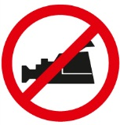
The AO Foundation reserves the right to film, photograph, and audio record during their events. Participants must understand that in this context they may appear in these recorded materials. The AO Foundation assumes participants agree that these recorded materials may be used for AO marketing and other purposes, and made available to the public.
Security
Security check at the entrance of the building. Wearing of a name tag is compulsory during lectures, workshops, and group discussions.

No insurance
The course organization does not take out insurance to cover any individual against accidents, thefts or other risks.

Mobile phone use
Mobile phone use is not allowed in the lecture halls and in other rooms during educational activities. Please be considerate of others by turning off your mobile phone.

Dress code
Casual

Course language
English

Course venue
Qubus Hotel Kraków
ul Nadwiślańska 6
30-527 Kraków
Tel.: +48 12 374 5 100
Fax.: +48 12 374 5 200
krakow@qubushotel.com
www.qubushotel.com/en/hotels/krakow/1/#main
Accommodation for participants
Book your hotel room until 04 April 2014, The number of rooms is limited.
Reservation and payment will be done individually by participants.
Accomodation is not included in the Registration fee, it has to be paid directly to the Hotel.
Room rates
Twin for sgl use 100 euro. Breakfast+VAT included.
Check in at 2 p.m.
Check out until 12:00 of the next day.
Hotel reservation & distances
For reservation please use the hotel registration form (download www.aotrauma.org) and fax or email it directly to the hotel.
Distances from to Hotel:
• Railway station 2,8 km
• Bus station 3 km
• Airport 13,7 km

Upcoming courses
Please visit our website for upcoming courses http://www.aotrauma.org/coursedirectory.aspx
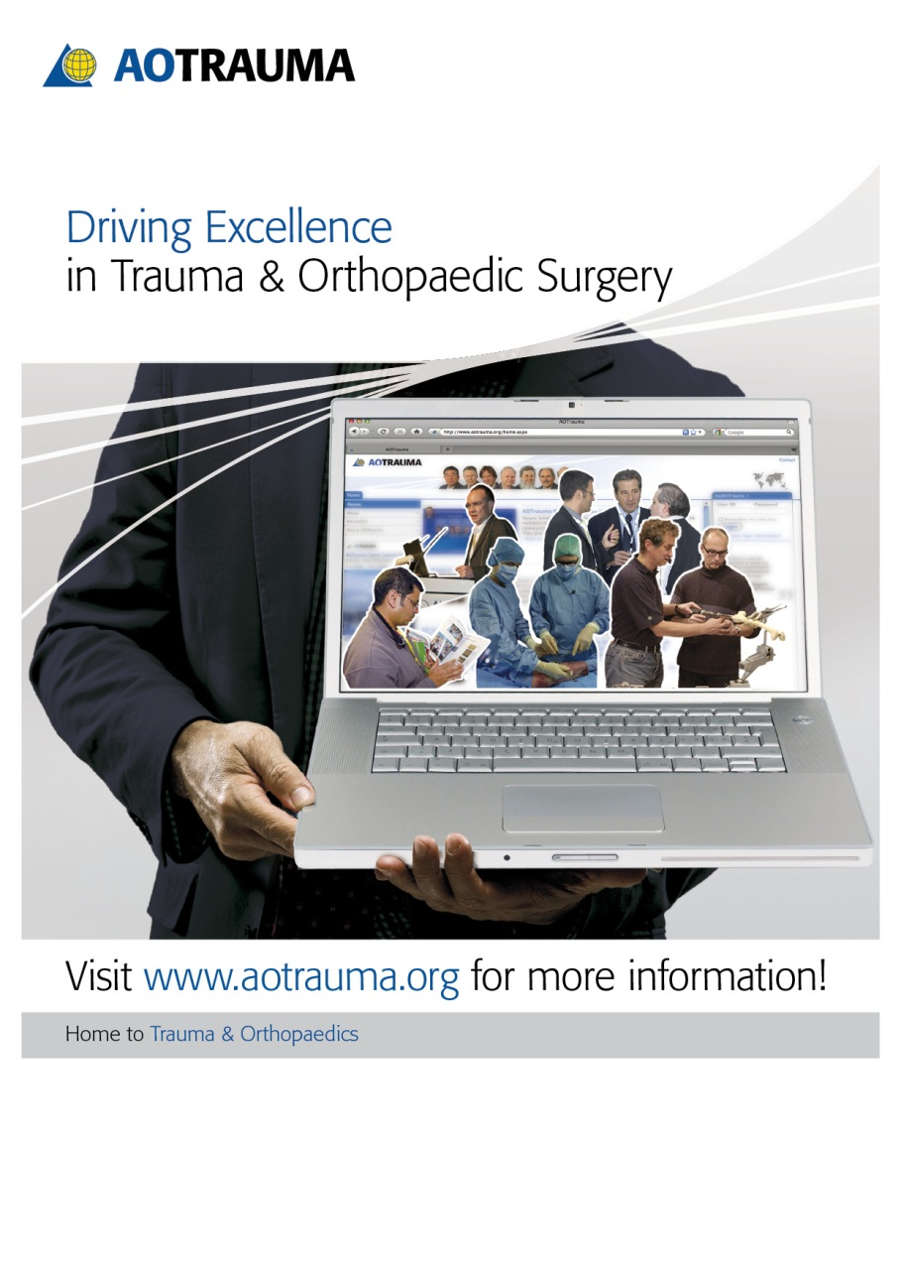

AOTrauma Europe Clavadelerstrasse 8, 7270 Davos, Switzerland
Phone +41 81 414 27 20, Fax +41 81 414 22 84, Email courses@aotrauma.org

Logistics and support provided by an educational grant from Synthes

